An open source electro-pneumatic controller for integrated microfluidic chips
Primary contact for the team
Adrien Hallou (ah691@cam.ac.uk)
Cavendish Laboratory, Department of Physics, University of Cambridge, Cambridge, CB3 0HE, UK.
Wellcome Trust/CRUK Gurdon Institute, University of Cambridge, Cambridge, CB2 1QN, UK.
Wellcome Trust/MRC Stem Cell Institute, University of Cambridge, Cambridge, CB2 1QR, UK

Team

Jean-Baptiste Lugagne (jean-baptiste.lugagne@inria.fr)
Laboratoire Matière et Systèmes Complexes, CNRS & Université Paris Diderot, 75013 Paris, France.
INRIA Saclay – Ile-de-France and Université Paris Saclay, 91120 Palaiseau, France.

Fabien Furfaro (fabien.furfaro@univ-paris-diderot.fr)
Laboratoire Matière et Systèmes Complexes, CNRS & Université Paris Diderot, 75013 Paris, France.

A.H: CAD design, prototyping, 3D printing, computer programming & python GUI.

J-B.L: CAD design, electronics, arduino and touchscreen programming & matlab GUI.

F.F: CAD design, computer programming & python GUI, device assembly & microfluidic testing.

Summary

Integrated microfluidic chips using multilayer valves (Quake's valves) make it possible to automate and parallelise quantitative biology experiments. Even if it is possible to buy or produce easily such microfluidic chips, there are no readily available solutions to control them, which slows their adoption by biologists. From our user experience, we have identified the key requirements to control such microfluidic systems, and our project aims at developing an open source, simple, cheap and robust controller. At the core of our design will be a 3D printed monolithic structure that will integrate the pneumatic and hydraulic circuitry, and the water reservoirs (circumventing the hassle of assembling watertight and pressure resistant parts). The electro-pneumatic actuation will be implemented using low-voltage solenoid valves driven by an arduino controller. The end user will be able to set and program the behaviours of the microfluidic valves in real time, either through a simple GUI on an integrated touchscreen or a usb-connected computer.

Proposal
The problem

As we improve our understanding of gene regulatory networks (GRNs) and cell-cell communication mechanisms in various cell types and biological contexts (microbiology, embryonic development, cancer, etc...), the dynamic mechanisms governing cellular signal processing and cell decision-making events progressively starts to unfold. Understanding these complex phenomena requires experimental systems to manipulate the internal states of cells, and to control, in space and time, their chemical and physical environment. For example, studies using time-varying perturbations of the chemical environment have allowed a deeper analysis of the structure and dynamics of various biochemical signaling cascades and GRNs (Bennett & Hasty 2009, Sorre et al. 2014). More recently, in silico control approaches have even made possible to control gene expression levels in real-time using cell-machine interfaces (Uhlendorf et al. 2012), opening the way to the precise study of the dynamics of intricate biomolecular networks and multicellular organisation.

The advent of soft lithography and microfluidic technologies have been transformative in the field, allowing to study, using live cell imaging, the behaviour of cell populations in response to a variety of controlled environmental inputs. The integration of the actuation framework directly into the microfluidic chips, using for example multilayer valves (Quake’s valves) (Unger et al. 2000, Melin & Quake 2007), have allowed through miniaturization the massive parallelization of the number of independent experiments on a single chip (Fig. 1), while allowing for better time and volume resolutions of the applied chemical inputs (Gómez-Sjöberg et al. 2007, Melin & Quake 2007).

However, these integrated microfluidic chips require a parallelized external pressure controller in order to actuate their numerous valves (Gómez-Sjöberg et al. 2007). To our knowledge, in spite of various commercial solutions to buy on-demand multilayer microfluidic devices, there are no readily-available solutions for an automated pressure-control system, each research group developing its own home-made solution (Fig. 2). Overall, we suspect that this added level of complexity might slow down the adoption of this promising technology by a broader spectrum of biological research groups, and our project aims at developing an open source, simple, cheap and robust parallelized external pressure controller for these integrated microfluidic devices.

Biological systems

Our proposed project aims at simplifying the use of integrated microfluidic chips in quantitative cell biology. These chips can be used to study the dynamics of cell-cell signaling, signal transduction and GRNs in a number of biological systems, with already published works using bacteria, yeast, mammalian or even human stem cells (Gómez-Sjöberg et al. 2007, Bennett & Hasty 2009, Uhlendorf et al. 2012, Sorre et al. 2014).

Hardware design goals & Project implementation

This all-in-one pneumatic controller is an ongoing project (Fig. 3), and through various design iterations and prototyping steps, we have identified the key features necessary for widespread adoption and routine use.

First of all, existing solutions rely all on connecting numerous hydraulic and pneumatic elements together (Fig. 2-1 & Fig. 3-3). Unfortunately, these connections tend to leak due to material wear and fatigue under sustained pressure, and might lead to experimental failures. They also require high levels of maintenance. Our proposed solution is to 3D print the entire hydraulic and pneumatic circuitry in a monolithic block, thus circumventing the connection problem.
The second pitfall we identified and started to address is the electronic design of these actuators. Current solutions are custom built for each setup and rely on outdated and unwieldy technologies (Fig. 2-2). We have already started designing and implementing valve control circuits (Fig. 3-1), with the final objective of developing a PCB controller based on (1) Surface Mounted Devices, to reduce cost and size and to allow for assembly by commercial services, (2) arduinos for ease-of-use and modifiability, and finally (3) i2c serial communications to allow for communication between several such devices and thus make the whole design modular.

Eventually, the last goal of our design is to simultaneously simplify user experience and empower tech-savvy experimentalists through both ergonomic graphical interfaces and open programming interfaces. We want to include a touchscreen interface for easy on-the-spot valves control, as well as both python and matlab graphical interfaces (GUIs) for computer control (which are already partially developed). We will also produce a detailed documentation on serial communication with the arduino as well as high-level python and matlab APIs to allow for computer-automated approaches.

For more information on our objectives and implementation decisions, see Table 1 below.

Outcomes and benefits

The final electro-pneumatic controller device will be simple to use, versatile, and robust. Not only would it help the technology to spread to research laboratories that could use it to systematically investigate the dynamics of complex GRNs and cell-cell communication systems, but it would also enable non-academic researchers to have access to a versatile, portable microfluidic platform for a reasonable price. Accessible integrated microfluidic solutions could then spread to citizen scientists and bio-hacker spaces, or burgeoning academic groups in emerging countries.

References
Bennett, M. R., & Hasty, J. (2009). Microfluidic devices for measuring gene network dynamics in single cells. Nature Reviews Genetics, 10(9), 628–638. https://doi.org/10.1038/nrg2625
Sorre, B., Warmflash, A., Brivanlou, A. H., & Siggia, E. (2014). Encoding of Temporal Signals by the TGF-β Pathway and Implications for Embryonic Patterning. Developmental Cell, 30(3), 334–342. https://doi.org/10.1016/j.devcel.2014.05.022
Uhlendorf, J., Miermont, A., Delaveau, T., Charvin, G., Fages, F., Bottani, S., … Hersen, P. (2012). Long-term model predictive control of gene expression at the population and single-cell levels. Proceedings of the National Academy of Sciences, 109(35), 14271–6. https://doi.org/10.1073/pnas.1206810109
Melin, J., & Quake, S. R. (2007). Microfluidic Large-Scale Integration: The Evolution of Design Rules for Biological Automation. Annual Review of Biophysics and Biomolecular Structure, 36(1), 213–231. https://doi.org/10.1146/annurev.biophys.36.040306.132646
Gómez-Sjöberg, R., Leyrat, A. A., Pirone, D. M., Chen, C. S., & Quake, S. R. (2007). Versatile, Fully Automated, Microfluidic Cell Culture System. Analytical Chemistry, 79(22), 8557–8563. https://doi.org/10.1021/ac071311w
Unger M.A., Chou H-P., Thorsen T., Scherer A. & Quake, S. R. (2000). Monolithic Microfabricated Valves and Pumps by Multilayer Soft Lithography. Science, 288(5463) 113-116. https://doi.org/10.1126/science.288.5463.113

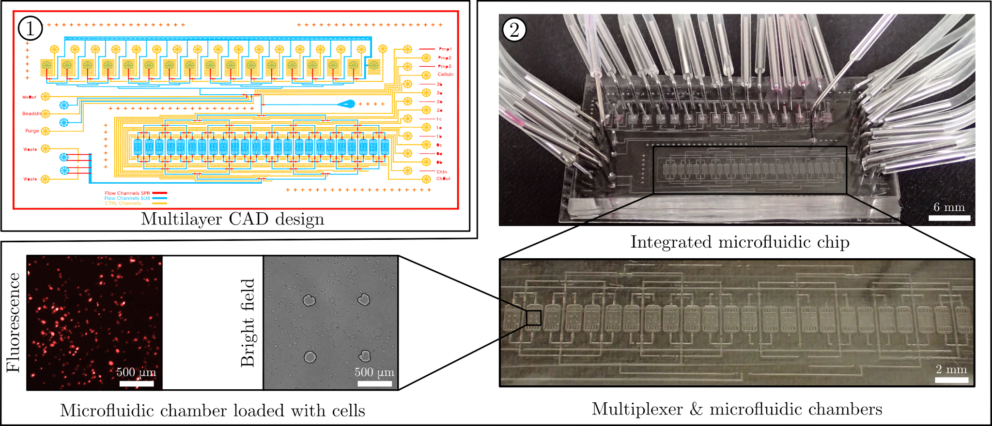
Figure 1. Multilayer integrated microfluidic chip. (1) CAD design of a multilayer integrated microfluidic chip. Each colour represents a separate layer (red & blue: flow layer, yellow: control layer ), each layer is printed as a photomask which will serve to produce a solid photoresist master. (2) After molding, curing and cutting each PDMS layer on its respective photoresist master, the integrated microfluidic chip is assembled and connected to the 32 valves of the electro-pneumatic controller thanks to soft plastic tubing. A 16 inlets input manifold and a multiplexer allow to address independently each of the 24 microfluidic chambers. A system of integrated Quake’s valves and peristaltic pumps allows to finely tune the chemical environment of each chamber, while a secondary input manifold allows to load cells. Here, Dictyostelium discoideum cells expressing RFP under the control of the act15 promoter are growing in a microfluidic chamber, HL5 growth medium is renewed according a precise and automated time schedule.
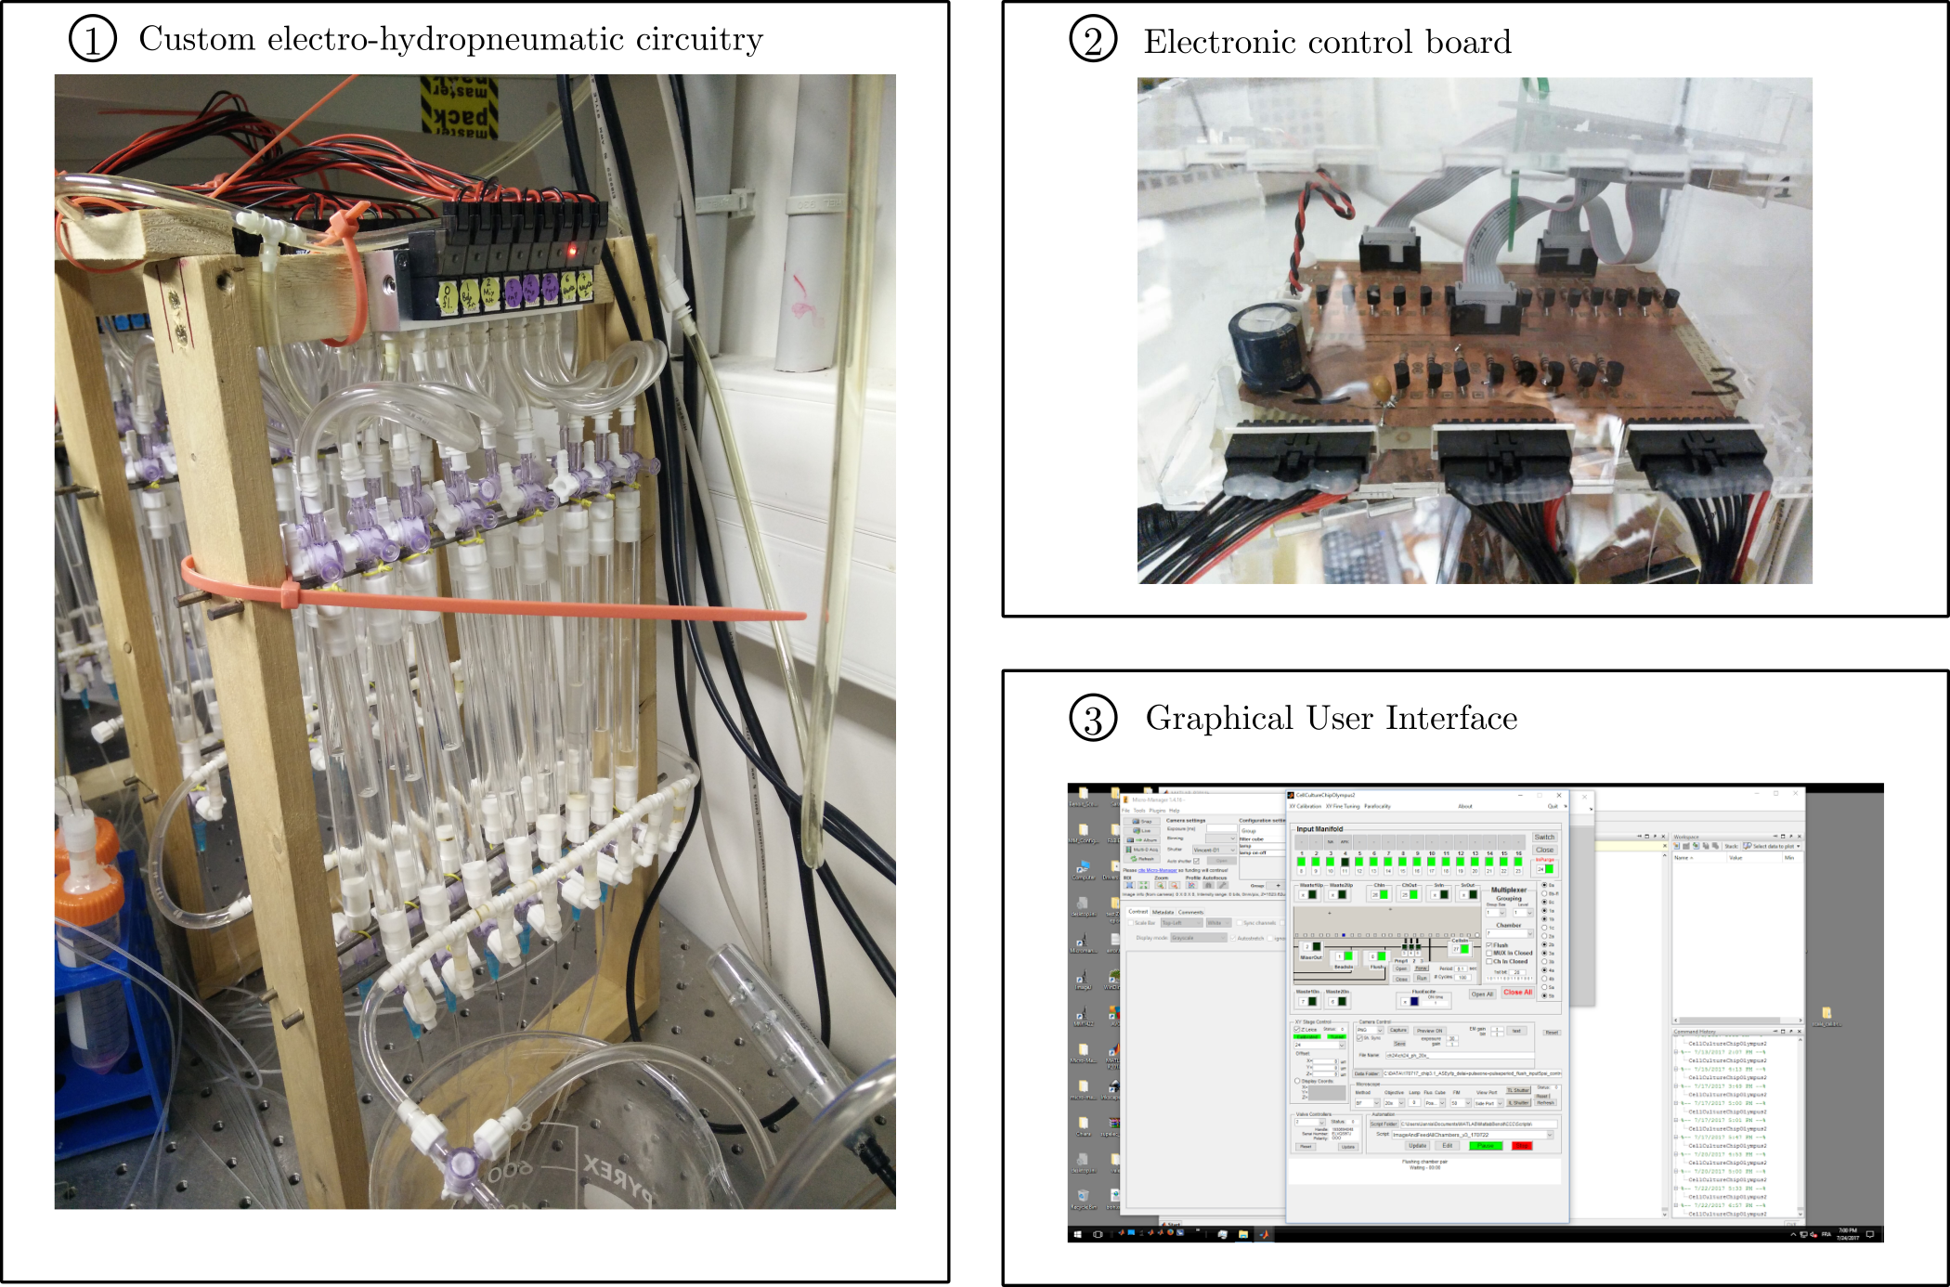
Figure 2. Electro-pneumatic controller V 1.0: Custom implementation of a parallelized controller. Original version of the microfluidic controller built in our lab. (1) Solenoid electro-pneumatic valves are connected to water reservoirs and then the microfluidics chip via soft plastic tubing and a number of different elements, which require all watertight and pressure-resistant connections. (2) Electronic circuitry is bulky and prone to failures. (3) Custom Matlab GUI developed in our lab for actuating the valves. Different interfaces are developed by each team for their specific purposes, reducing re-usability by other labs.

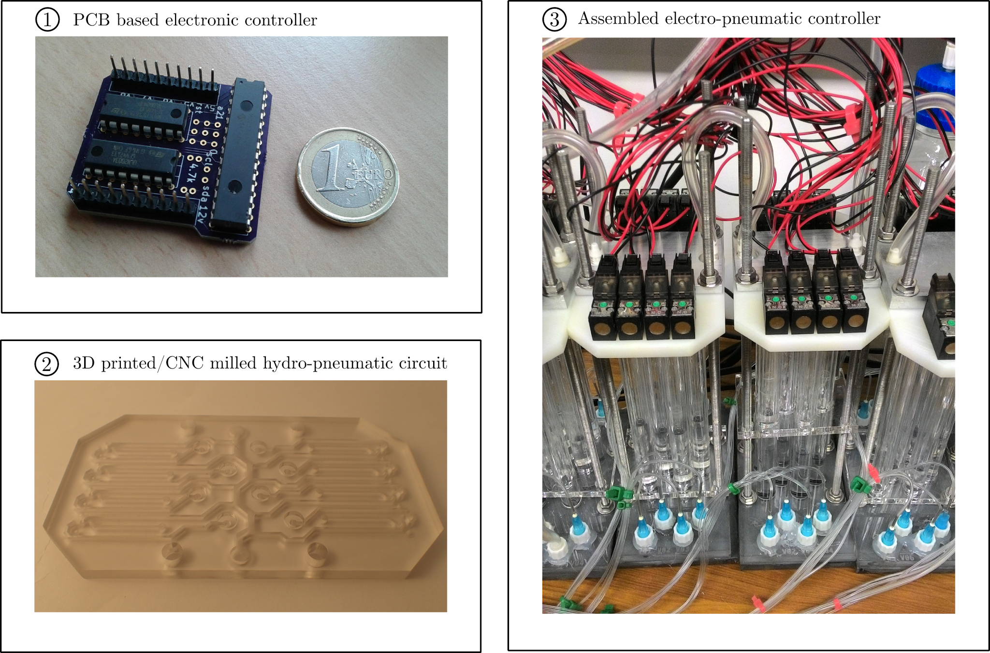
Figure 3. Electro-pneumatic controller V 2.0: A more integrated device. (1) We started by miniaturizing the electronics to integrate it onto the device. The PCB prototype presented here can drive up to 8 solenoid valves while receiving commands from an arduino chip via an i2c serial bus. Up to 8 of these modules can be connected to an arduino controller. (2-3) A more compact version of the hydro-pneumatic circuitry. 3D printed and/or CNC-milled circuitry and solenoid valves are used to selectively pressurize water reservoirs and then open or close valves integrated into the microfluidic chips. Although this system works well and greatly reduces the size of the whole setup, prolonged mechanical stress on the assembled parts led to water leaks after a few weeks in operation. This observation lead us to the current design of a hydro-pneumatic circuit entirely 3D printed in one block, thus circumventing the hassle of assembly and maintenance.

General design | Size: One device should be able to control up to 32 valves independently, and be roughly 300x200x100 mm in size.
 | Modularity: It should be possible to connect several controllers together, and have them acting as a single controller s.t. users can easily control 32, 64, 96 etc… valves through a single interface.
 | Portability: The only inputs required to use the controller should be electrical power and compressed air (+ optionally a USB connection to a computer).
Hydropneumatics | A single 3D printed hydropneumatic block that contains the reservoirs and circuitry for driving up to 32 valves.
Electronics | SMDs should be used to lower costs and make automated assembly possible.
 | An arduino will drive the valves for versatility and simplicity.
User interface | An integrated touchscreen will allow for simple on-the-spot valves manipulation.
 | Python and Matlab GUIs will be implemented for computer control of the device.
 | Python and Matlab APIs will be provided for programming valves states.
 | Serial commands for interacting with the arduino will be documented and the whole design will be open-source.

Table 1. Scope statement for version 3.0 of the electro-pneumatic controller. Our goal is to obtain a modular, all-in-one device that can be quickly set up anywhere and controlled on-the-spot or automated.

